**Assignment 7.5**

**Question:** Write a map only job for the word count program and set the output format as sequence file.

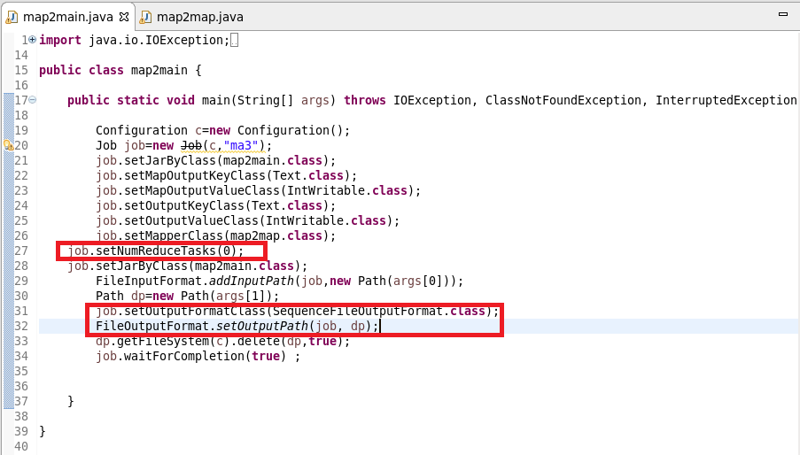

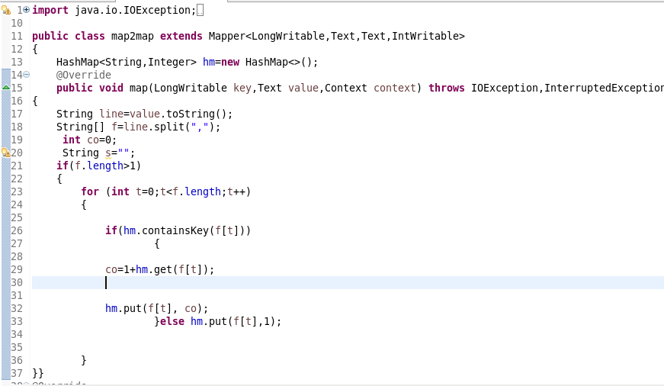

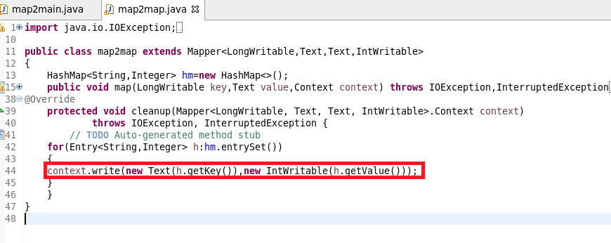

**OUTPUT:**

